**Hasil *Statistical Learning* untuk pembahasan.**

Muhammad Kevin A (19/445592/PA/19416)

Referensi:

* [The Elements of Statistical Learning - Google Books](https://www.google.co.id/books/edition/The_Elements_of_Statistical_Learning/yPfZBwAAQBAJ?hl=id&gbpv=0)
* [Statistical Learning with Math and Python - Google Books](https://www.google.co.id/books/edition/Statistical_Learning_with_Math_and_Pytho/2ok7EAAAQBAJ?hl=id&gbpv=0)
* [HSI2020_takigawa1_highres (itakigawa.github.io)](https://itakigawa.github.io/hsi2020/HSI2020_takigawa1_highres.pdf)

1. **EKSPLORASI DATA**
2. **Statistika Deskriptif**

|  |  |  |  |  |  |  |  |  |
| --- | --- | --- | --- | --- | --- | --- | --- | --- |
|  | Jumlah | Rata-rata | Simpangan Baku | Min | Kuartil 1 | Median | Kuartil 3 | Maks |
| C | 33.0 | 17.96 | 7.06 | 7.70 | 12.0 | 20.00 | 22.50 | 30.0 |
| V | 33.0 | 18.05 | 6.15 | 10.00 | 14.0 | 15.00 | 26.00 | 26.0 |
| F | 33.0 | 3.82 | 5.11 | 0.05 | 0.5 | 1.00 | 12.00 | 12.0 |
| R | 33.0 | 1.66 | 1.14 | 0.33 | 1.0 | 1.00 | 2.33 | 4.0 |
| ω | 33.0 | 417.58 | 465.93 | 0.00 | 0.0 | 300.00 | 900.00 | 2000.0 |
| L | 33.0 | 14.15 | 2.76 | 10.00 | 12.0 | 15.00 | 15.00 | 22.0 |
| D | 33.0 | 491.31 | 334.91 | 105.00 | 215.0 | 471.58 | 680.00 | 1800.0 |

1. **Visualisasi Sebaran Data**

1. **Visualisasi Hubungan Antar Variabel**

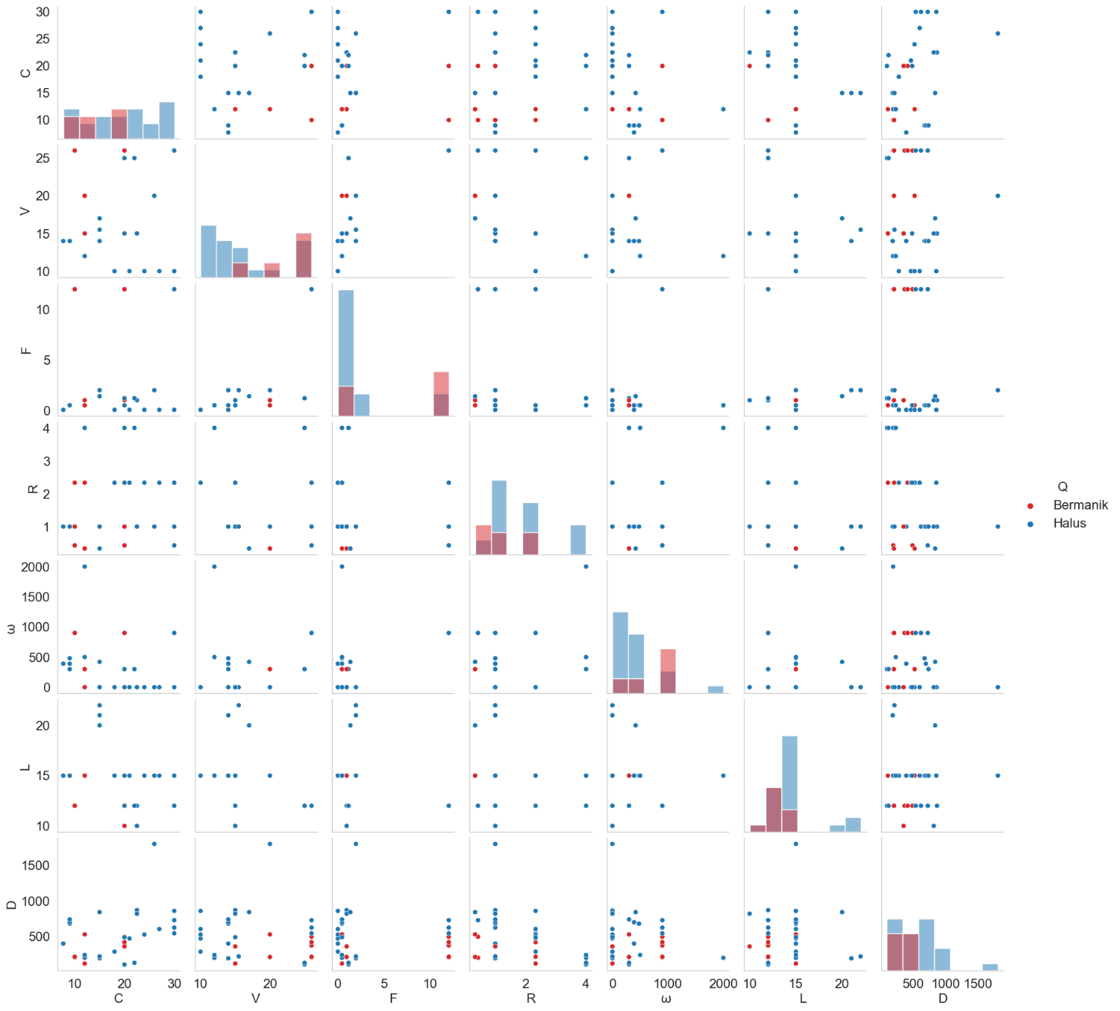

1. **REGRESI LINEAR**
2. **Regresi Linear Sederhana**

|  |  |
| --- | --- |
| Variabel Keluaran: | D |
| Jumlah Variabel Masukan: | 6 |
| Model: | Regresi linear sederhana |
| Metode: | RSS |
| Jumlah Observasi: | 33 |
| R2: | 0.461 |

|  |  |  |  |  |  |  |
| --- | --- | --- | --- | --- | --- | --- |
|  | Koefisien |  | -statistik | P>|t| | Interval Konfidensi | |
| [0.025 | 0.975] |
| Intersep | 1.804e-16 | 0.144 | 1.25e-15 | 1.000 | -0.296 | 0.296 |
| C | 0.5931 | 0.170 | 3.492 | 0.002 | 0.244 | 0.942 |
| V | -0.0178 | 0.272 | -0.065 | 0.948 | -0.577 | 0.541 |
| F | -0.5163 | 0.328 | -1.572 | 0.128 | -1.191 | 0.159 |
| R | -0.5895 | 0.169 | -3.480 | 0.002 | -0.938 | -0.241 |
| ω | 0.2222 | 0.219 | 1.012 | 0.321 | -0.229 | 0.673 |
| L | -0.0679 | 0.174 | -0.390 | 0.700 | -0.426 | 0.290 |

1. **Plot Residu**

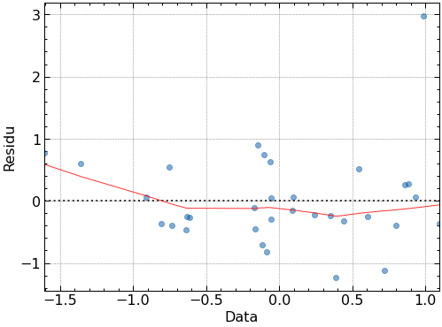

1. **Deteksi *outlier* menggunakan nilai**

: Titik leverage (Sumbu horizontal)

: Titik *studentized residual* (Sumbu vertikal)

**:** Jarak Cook (Semakin besar lingkaran, semakinbesar nilai **)**

Data Outlier:

|  |  |  |  |  |  |  |  |  |  |
| --- | --- | --- | --- | --- | --- | --- | --- | --- | --- |
| C | V | F | R | ω | L | D | Q | Sumber PET | Referensi |
| 26 | 20 | 2 | 1 | 0 | 15 | 1800 | Halus | Botol bekas PET (Sharalau) | Khorram *et al*., 2017 |
| 12 | 12 | 0.5 | 4 | 2000 | 15 | 200 | Halus | Butiran PET (IPRT) | Abassi *et al*., 2018 |

1. **Regresi linear sederhana setelah data *outlier* dihapus.**

|  |  |
| --- | --- |
| Variabel Keluaran: | D |
| Jumlah Variabel Masukan: | 6 |
| Model: | Regresi linear sederhana |
| Metode: | RSS |
| Jumlah Observasi: | 31 |
| R2: | 0.693 |

|  |  |  |  |  |  |  |
| --- | --- | --- | --- | --- | --- | --- |
|  | Koefisien |  | -statistik | P>|t| | Interval Konfidensi | |
| **[0.025** | **0.975]** |
| const | 2.047e-16 | 0.113 | 1.81e-15 | 1.000 | -0.234 | 0.234 |
| C | 0.7211 | 0.142 | 5.078 | 0.000 | 0.428 | 1.014 |
| V | -0.6509 | 0.229 | -2.847 | 0.009 | -1.123 | -0.179 |
| F | -0.9328 | 0.327 | -2.851 | 0.009 | -1.608 | -0.258 |
| R | -0.6145 | 0.125 | -4.914 | 0.000 | -0.873 | -0.356 |
| ω | 1.1324 | 0.308 | 3.682 | 0.001 | 0.498 | 1.767 |
| L | -0.1720 | 0.138 | -1.248 | 0.224 | -0.457 | 0.113 |

Plot residu setelah data *outlier* dihapus

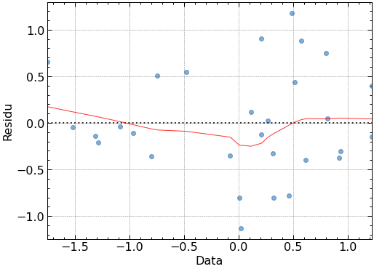

1. **Regresi linear sederhana untuk semua kombinasi variabel yang mungkin**

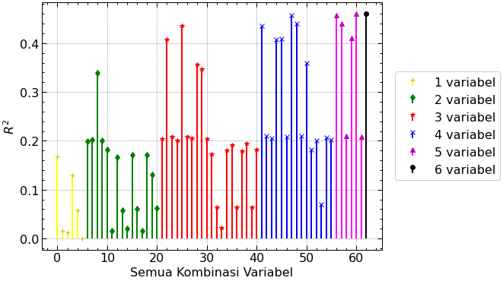

|  |  |
| --- | --- |
| Kombinasi Variabel |  |
| (C, V, F, R, ω, L) | 0.461135 |
| (C, F, R, ω, L) | 0.461046 |
| (C, V, F, R, ω) | 0.457986 |
| (C, F, R, ω) | 0.457969 |
| (C, V, F, R, L) | 0.439904 |
| (C, F, R, L) | 0.439478 |
| (C, V, F, R) | 0.436097 |
| (C, F, R) | 0.436058 |
| (C, V, R, ω, L) | 0.40993 |
| (C, V, R, L) | 0.409392 |

1. **Regresi linear sederhana dengan regularisasi**

**Tabel Koefisien Regresi Lasso**

|  |  |  |  |  |  |  |  |
| --- | --- | --- | --- | --- | --- | --- | --- |
| Lambda | 0.010 | 0.025 | 0.040 | 0.055 | 0.070 | 0.085 | 0.100 |
| C | 0.565 | 0.520 | 0.472 | 0.450 | 0.427 | 0.405 | 0.382 |
| V | 0.000 | 0.000 | 0.000 | 0.000 | 0.000 | 0.000 | 0.000 |
| F | -0.463 | -0.360 | -0.263 | -0.238 | -0.213 | -0.188 | -0.163 |
| R | -0.552 | -0.496 | -0.442 | -0.418 | -0.394 | -0.371 | -0.347 |
| ω | 0.168 | 0.085 | 0.001 | 0.000 | 0.000 | 0.000 | 0.000 |
| L | -0.046 | -0.016 | 0.000 | 0.000 | 0.000 | 0.000 | 0.000 |
|  | **0.459** | **0.448** | **0.429** | **0.422** | **0.413** | **0.402** | **0.389** |

1. **Regularisasi regresi linear dengan suku interaksi**

|  |  |
| --- | --- |
| Variabel Keluaran: | D |
| Jumlah Variabel Masukan: | 21 |
| Model: | Regresi linear dengan suku interaksi |
| Metode: | RSS |
| Jumlah Observasi: | 33 |
| R2: | 0.990 |

**Catatan penting:**

*Problems with R-squared statistic : Its value never decreases no matter the number of variables we add to our regression model. That is, even if we are adding redundant variables to the data, the value of R-squared does not decrease. It either remains the same or increases with the addition of new independent variables.*

[Coefficient of determination - Wikipedia](https://en.wikipedia.org/wiki/Coefficient_of_determination#Inflation_of_R2)

|  |  |  |  |  |  |  |
| --- | --- | --- | --- | --- | --- | --- |
|  | Koefisien |  | -statistik | P>|t| | Interval Konfidensi | |
| **[0.025** | **0.975]** |
| const | 0 | 0.031 | 0 | 1.000 | -0.067 | 0.067 |
| C | 8.0018 | 2.219 | 3.606 | 0.004 | 3.118 | 12.886 |
| V | 40.0545 | 10.523 | 3.806 | 0.003 | 16.893 | 63.216 |
| F | 29.8049 | 32.793 | 0.909 | 0.383 | -42.371 | 101.981 |
| R | 113.6203 | 15.980 | 7.110 | 0.000 | 78.449 | 148.792 |
| ω | 126.3254 | 17.036 | 7.415 | 0.000 | 88.829 | 163.822 |
| L | 30.0297 | 4.635 | 6.478 | 0.000 | 19.827 | 40.232 |
| C V | -0.8805 | 1.241 | -0.710 | 0.493 | -3.611 | 1.850 |
| C F | 0.6480 | 3.065 | 0.211 | 0.836 | -6.097 | 7.393 |
| C R | -0.3332 | 0.213 | -1.565 | 0.146 | -0.802 | 0.135 |
| C ω | -2.6290 | 2.966 | -0.886 | 0.394 | -9.158 | 3.900 |
| C L | -5.8562 | 1.784 | -3.282 | 0.007 | -9.783 | -1.929 |
| V F | -54.0295 | 12.693 | -4.257 | 0.001 | -81.967 | -26.092 |
| V R | -28.1357 | 4.400 | -6.394 | 0.000 | -37.821 | -18.451 |
| V ω | -103.2591 | 17.249 | -5.986 | 0.000 | -141.225 | -65.294 |
| V L | -15.3784 | 5.751 | -2.674 | 0.022 | -28.037 | -2.720 |
| F R | 3.3562 | 0.999 | 3.359 | 0.006 | 1.157 | 5.555 |
| F ω | 70.5901 | 16.865 | 4.186 | 0.002 | 33.471 | 107.710 |
| F L | -19.0289 | 19.995 | -0.952 | 0.362 | -63.037 | 24.979 |
| R ω | -9.7382 | 1.734 | -5.615 | 0.000 | -13.555 | -5.921 |
| R L | -89.7022 | 12.412 | -7.227 | 0.000 | -117.022 | -62.383 |
| ω L | -52.6762 | 6.652 | -7.919 | 0.000 | -67.316 | -38.036 |

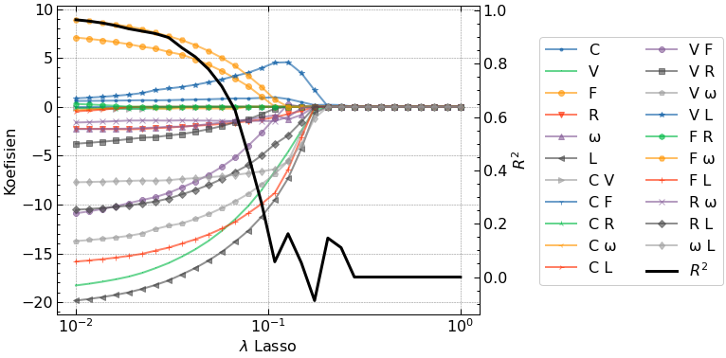

|  |  |  |  |  |  |  |  |
| --- | --- | --- | --- | --- | --- | --- | --- |
| Lambda | 0.010 | 0.025 | 0.040 | 0.055 | 0.070 | 0.085 | 0.100 |
| C | 0.586 | 0.652 | 0.726 | 0.796 | 0.866 | 0.875 | 0.940 |
| V | -18.282 | -16.631 | -14.805 | -12.996 | -11.186 | -9.414 | -7.606 |
| F | 7.081 | 6.025 | 4.996 | 3.845 | 2.697 | 1.618 | 0.470 |
| R | -2.251 | -2.195 | -1.970 | -1.788 | -1.607 | -1.402 | -1.217 |
| ω | -2.290 | -2.152 | -1.960 | -1.661 | -1.365 | -1.208 | -0.919 |
| L | -19.830 | -18.333 | -16.691 | -15.104 | -13.516 | -12.029 | -10.443 |
| C V | -0.130 | 0.000 | 0.000 | 0.000 | 0.000 | 0.000 | 0.000 |
| C F | 0.000 | 0.000 | 0.000 | 0.000 | 0.000 | 0.000 | 0.000 |
| C R | -0.150 | -0.152 | 0.000 | 0.000 | 0.000 | 0.000 | 0.000 |
| C ω | -0.358 | -0.183 | -0.156 | -0.177 | -0.199 | 0.000 | 0.000 |
| C L | -0.471 | 0.000 | 0.000 | 0.000 | 0.000 | 0.000 | 0.000 |
| V F | -10.904 | -9.336 | -7.833 | -6.383 | -4.933 | -3.382 | -1.926 |
| V R | -3.779 | -3.143 | -2.635 | -2.068 | -1.501 | -1.043 | -0.482 |
| V ω | -13.741 | -12.570 | -11.618 | -10.550 | -9.484 | -8.474 | -7.411 |
| V L | 0.861 | 1.672 | 2.187 | 2.713 | 3.237 | 3.705 | 4.226 |
| F R | 0.288 | 0.000 | 0.000 | 0.000 | 0.000 | 0.000 | 0.000 |
| F ω | 8.899 | 7.662 | 6.453 | 5.208 | 3.962 | 2.654 | 1.408 |
| F L | -15.839 | -14.787 | -13.690 | -12.640 | -11.590 | -10.461 | -9.408 |
| R ω | -1.615 | -1.404 | -1.403 | -1.436 | -1.469 | -1.443 | -1.471 |
| R L | -10.538 | -9.766 | -8.648 | -7.566 | -6.483 | -5.518 | -4.438 |
| ω L | -7.725 | -7.576 | -7.329 | -7.136 | -6.939 | -6.717 | -6.516 |
| R2 | 0.965 | 0.916 | 0.837 | 0.735 | 0.600 | 0.380 | 0.163 |

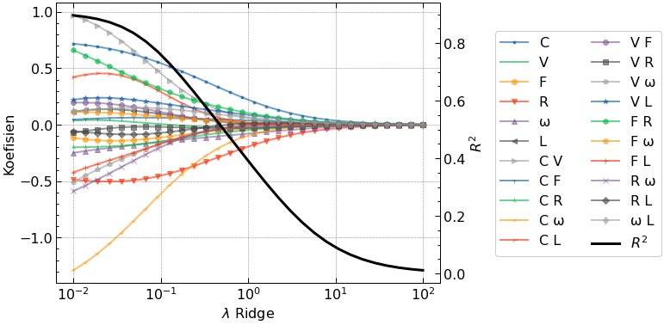

1. **Regularisasi Lasso untuk regresi linear dengan suku polinomial derajat 3**

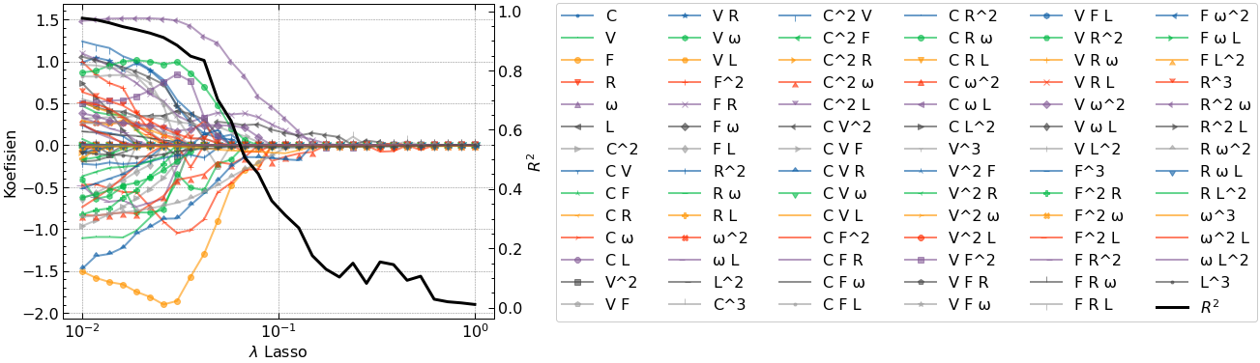

**Regresi Lasso untuk lambda = 0.04**

|  |  |
| --- | --- |
| Variabel Keluaran: | D |
| Jumlah Variabel Masukan: | 30 |
| Model: | Regresi linear dengan suku polinomial orde 3 |
| Metode: | RSS |
| Jumlah Observasi: | 30 |
| R2: | 0.840 |

|  |  |  |  |  |  |  |
| --- | --- | --- | --- | --- | --- | --- |
|  | coef | std err | t | P>|t| | [0.025 | 0.975] |
| F | -1.3030 | 3.214 | -0.405 | 0.724 | -15.133 | 12.527 |
| L | 0.3292 | 1.560 | 0.211 | 0.852 | -6.382 | 7.041 |
| C ω | -0.8580 | 1.850 | -0.464 | 0.688 | -8.816 | 7.100 |
| V R | 0.1888 | 1.557 | 0.121 | 0.915 | -6.509 | 6.886 |
| V ω | -0.4568 | 1.770 | -0.258 | 0.820 | -8.073 | 7.159 |
| F R | 0.3559 | 4.671 | 0.076 | 0.946 | -19.744 | 20.456 |
| R^2 | -0.1452 | 1.278 | -0.114 | 0.920 | -5.645 | 5.354 |
| L^2 | -0.0097 | 0.953 | -0.010 | 0.993 | -4.110 | 4.090 |
| C^2 V | 0.2732 | 11.306 | 0.024 | 0.983 | -48.373 | 48.919 |
| C^2 ω | -0.4010 | 6.509 | -0.062 | 0.956 | -28.408 | 27.607 |
| C V^2 | 0.0549 | 8.107 | 0.007 | 0.995 | -34.825 | 34.935 |
| C V F | 0.2958 | 3.849 | 0.077 | 0.946 | -16.263 | 16.855 |
| C V R | -0.5890 | 8.452 | -0.070 | 0.951 | -36.953 | 35.775 |
| C F^2 | 0.2395 | 6.725 | 0.036 | 0.975 | -28.696 | 29.175 |
| C R ω | 0.7383 | 3.399 | 0.217 | 0.848 | -13.887 | 15.363 |
| V F^2 | 0.3584 | 4.970 | 0.072 | 0.949 | -21.027 | 21.744 |
| V ω^2 | 0.1972 | 6.719 | 0.029 | 0.979 | -28.713 | 29.107 |
| V L^2 | 0.1119 | 5.118 | 0.022 | 0.985 | -21.910 | 22.133 |
| F^3 | 0.0885 | 2.204 | 0.040 | 0.972 | -9.396 | 9.573 |
| R^3 | 0.0863 | 3.847 | 0.022 | 0.984 | -16.464 | 16.636 |
| R^2 ω | 1.3335 | 2.827 | 0.472 | 0.684 | -10.830 | 13.497 |
| R ω^2 | -0.6226 | 15.377 | -0.040 | 0.971 | -66.785 | 65.540 |
| L^3 | -0.0381 | 0.768 | -0.050 | 0.965 | -3.342 | 3.266 |

Model regresi polinomial orde 3

-1.303*F +0.3292*L +-0.858*C ω +0.1888*V R +-0.4568*V ω +0.3559*F R +-0.1452*R^2 +-0.0097*L^2 +0.2732*C^2 V +-0.401*C^2 ω +0.0549*C V^2 +0.2958*C V F +-0.589*C V R +0.2395*C F^2 +0.7383*C R ω +0.3584*V F^2 +0.1972*V ω^2 +0.1119*V L^2 +0.0885*F^3 +0.0863*R^3 +1.3335*R^2 ω +-0.6226*R ω^2 +-0.0381*L^3

Plot kontur untuk model regresi polinomial orde 3 (satuan dalam simpangan baku)

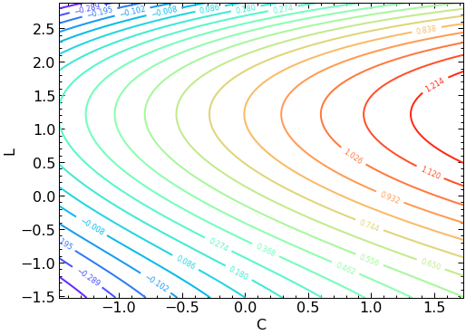

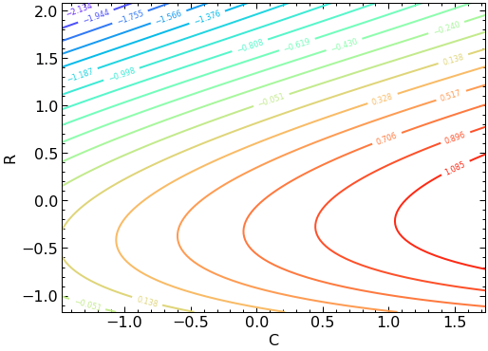 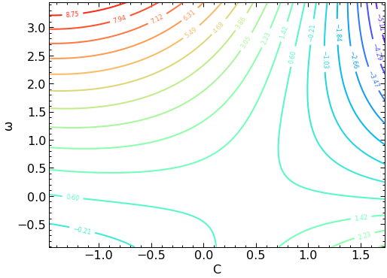

1. **REGRESI LOGISTIK**

|  |  |  |  |  |  |  |
| --- | --- | --- | --- | --- | --- | --- |
|  | coef | std err | z | P>|z| | [0.025 | 0.975] |
| Intercept | 3.3576 | 1.676 | 2.004 | 0.045 | 0.073 | 6.642 |
| C | 3.8344 | 2.003 | 1.914 | 0.056 | -0.092 | 7.760 |
| V | -2.8344 | 1.759 | -1.611 | 0.107 | -6.283 | 0.614 |
| F | -0.2089 | 1.341 | -0.156 | 0.876 | -2.837 | 2.419 |
| R | 1.1778 | 0.916 | 1.286 | 0.198 | -0.617 | 2.972 |
| ω | 0 | 0 | nan | nan | 0 | 0 |
| L | 3.5695 | 2.132 | 1.674 | 0.094 | -0.610 | 7.74 |

|  |  |  |  |  |  |  |  |  |
| --- | --- | --- | --- | --- | --- | --- | --- | --- |
|  | C | V | F | R | ω | L | Halus | prob_halus(%) |
| 0 | -1.145211 | 1.313551 | 1.624006 | -1.088160 | 1.051462 | -0.790844 | 0 | 0.010 |
| 1 | -1.145211 | 1.313551 | 1.624006 | -0.581206 | 1.051462 | -0.790844 | 0 | 0.018 |
| 2 | -1.145211 | 1.313551 | 1.624006 | 0.601689 | 1.051462 | -0.790844 | 0 | 0.074 |
| 3 | 0.293387 | 1.313551 | 1.624006 | -1.088160 | 1.051462 | -0.790844 | 0 | 2.450 |
| 4 | 0.293387 | 1.313551 | 1.624006 | -0.581206 | 1.051462 | -0.790844 | 0 | 4.364 |
| 5 | 0.293387 | 1.313551 | 1.624006 | 0.601689 | 1.051462 | -0.790844 | 0 | 15.525 |
| 6 | 1.731985 | 1.313551 | 1.624006 | -1.088160 | 1.051462 | -0.790844 | 1 | 86.197 |
| 7 | 1.731985 | 1.313551 | 1.624006 | -0.581206 | 1.051462 | -0.790844 | 1 | 91.900 |
| 8 | 1.731985 | 1.313551 | 1.624006 | 0.601689 | 1.051462 | -0.790844 | 1 | 97.859 |
| 9 | -1.476089 | -0.668035 | -0.748938 | -0.581206 | -0.060102 | 0.311882 | 1 | 54.396 |
| 10 | -1.289071 | -0.668035 | -0.659580 | -0.581206 | 0.136056 | 0.311882 | 1 | 70.573 |
| 11 | -1.289071 | -0.668035 | -0.659580 | -0.581206 | -0.060102 | 0.311882 | 1 | 70.573 |
| 12 | -1.289071 | -0.668035 | -0.659580 | -0.581206 | -0.256261 | 0.311882 | 1 | 70.573 |
| 13 | 0.653036 | -0.502902 | -0.560294 | -0.581206 | -0.910122 | -0.790844 | 1 | 98.009 |
| 14 | 0.005667 | -1.328563 | -0.748422 | 0.601689 | -0.910122 | 0.311882 | 1 | 99.989 |
| 15 | 0.437247 | -1.328563 | -0.748422 | 0.601689 | -0.910122 | 0.311882 | 1 | 99.998 |
| 16 | 0.868826 | -1.328563 | -0.748422 | 0.601689 | -0.910122 | 0.311882 | 1 | 100.000 |
| 17 | 1.300405 | -1.328563 | -0.748422 | 0.601689 | -0.910122 | 0.311882 | 1 | 100.000 |
| 18 | 1.731985 | -1.328563 | -0.748422 | 0.601689 | -0.910122 | 0.311882 | 1 | 100.000 |
| 19 | 0.293387 | -0.502902 | -0.560294 | -0.581206 | -0.910122 | -1.525995 | 0 | 47.336 |
| 20 | 0.653036 | -0.502902 | -0.560294 | -0.581206 | -0.910122 | -1.525995 | 1 | 78.115 |
| 21 | 0.293387 | 1.148419 | -0.520580 | 2.080306 | -0.256261 | -0.790844 | 1 | 72.382 |
| 22 | 0.581106 | 1.148419 | -0.520580 | 2.080306 | -0.256261 | -0.790844 | 1 | 88.762 |
| 23 | -0.857492 | 0.322758 | -0.659580 | -1.172653 | -0.256261 | 0.311882 | 0 | 27.382 |
| 24 | -0.857492 | 0.322758 | -0.560294 | -1.172653 | -0.256261 | 0.311882 | 0 | 26.972 |
| 25 | -0.425912 | -0.172638 | -0.480865 | -1.172653 | 0.005284 | 2.149759 | 1 | 99.982 |
| 26 | 1.156546 | 0.322758 | -0.361721 | -0.581206 | -0.910122 | 0.311882 | 1 | 99.938 |
| 27 | -0.857492 | -0.998299 | -0.659580 | 2.080306 | 3.448953 | 0.311882 | 1 | 99.864 |
| 28 | -0.857492 | -0.998299 | -0.659580 | 2.080306 | 0.179647 | 0.311882 | 1 | 99.864 |
| 29 | -0.425912 | -0.668035 | -0.361721 | -0.581206 | -0.910122 | 2.517334 | 1 | 99.999 |
| 30 | -0.425912 | -0.420336 | -0.361721 | -0.581206 | -0.910122 | 2.884910 | 1 | 100.000 |
| 31* | -0.857492 | -0.502902 | -0.659580 | 0.601689 | -0.910122 | 0.311882 | 0 | 96.937 |
| 32 | 0.293387 | -0.502902 | -0.659580 | 0.601689 | -0.910122 | 0.311882 | 1 | 99.962 |

**\*Data Anomali**

**Plot probabilitas untuk 3 variabel yang paling signifikan**

